DSA06 – Data Handling and Visualization
Activity: Identify Skewness using Violin Plots
Name | Devamada Hemasree
R.No / Reg. No | 11 / 192524114

Part A – Answer Key at a Glance [18 marks]
For every violin: skew (1 mark) and the relation of the mean to the median (0.5 mark). The correct choice is highlighted in red.
Chart | Violin | Skew (circle one) | Mean vs Median (circle)
Chart 1 | Store 2 | Right / Left / Symm. | Mean > / < / ~ Median
 | Store 4 | Right / Left / Symm. | Mean > / < / ~ Median
 | Store 5 | Right / Left / Symm. | Mean > / < / ~ Median
Chart 2 | Model P | Right / Left / Symm. | Mean > / < / ~ Median
 | Model Q | Right / Left / Symm. | Mean > / < / ~ Median
 | Model S | Right / Left / Symm. | Mean > / < / ~ Median
Chart 3 | Dept ECE | Right / Left / Symm. | Mean > / < / ~ Median
 | Dept CSE | Right / Left / Symm. | Mean > / < / ~ Median
 | Dept MECH | Right / Left / Symm. | Mean > / < / ~ Median
Chart 4 | Brand X | Right / Left / Symm. | Mean > / < / ~ Median
 | Brand V | Right / Left / Symm. | Mean > / < / ~ Median
 | Brand Y | Right / Left / Symm. | Mean > / < / ~ Median

Pattern check: in every chart there is one right-skewed, one left-skewed and one symmetric violin. Numbers such as ≈ 24 are read from the axis, so they are approximate.

Part B – Short Answers [2 marks]
- B1 [1]: Brand X has its tail towards the higher (upper, right-hand) side, so it is right-skewed. The median is the better measure of a typical fuel efficiency, because the few high values in the tail pull the mean up, but they cannot move the median.
- B2 [1]: ggplot(df, aes(x = group, y = value)) + geom_violin() + stat_summary(fun = median, geom = "point")
Concept Overview: Reading Skewness from a Violin Plot

What a violin plot shows
- Shape = density: the violin is a mirror-image curve. Where it is wide, many values lie there. Where it is thin, only a few values lie there.
- White dot = median: the middle value. Half of the data is above it and half is below it.
- The mean is not drawn. We work it out from the shape (see the rule below).
- Flat wide end: the violin is cut at the smallest or largest data value. A flat wide end means many values are piled up at that end.

Skewness: Right, Left or Symmetric
Skewness tells us whether the distribution is balanced or stretched to one side. The skew is named after the side of the long, thin tail, not after the side where the bulk of the data is. In a vertical violin, "right" means towards higher values (upwards) and "left" means towards lower values (downwards).
Type | What the violin looks like | Median dot | Mean vs Median
Right (positive) skew | Widest part is low. A long thin tail stretches up to the high values. | Low in the range, near the wide end | Mean > Median
Left (negative) skew | Widest part is high. A long thin tail stretches down to the low values. | High in the range, near the wide end | Mean < Median
Symmetric | Balanced shape. Both tails are equally long. | At the centre, at the widest part | Mean ≈ Median

Why the mean follows the tail
- The mean uses every value, so a few extreme values in the tail drag it towards the tail.
- The median only depends on the middle position, so extreme values hardly move it.
- Therefore: right skew → mean above median; left skew → mean below median; symmetric → they are about equal.

4 steps to answer each violin
- Step 1: find the widest part (where most of the data is).
- Step 2: find the long thin tail: which side does it stretch to?
- Step 3: check the median dot: is it at the centre, or close to the wide end?
- Step 4: tail up = Right skew (mean > median); tail down = Left skew (mean < median); balanced = Symmetric (mean ≈ median).
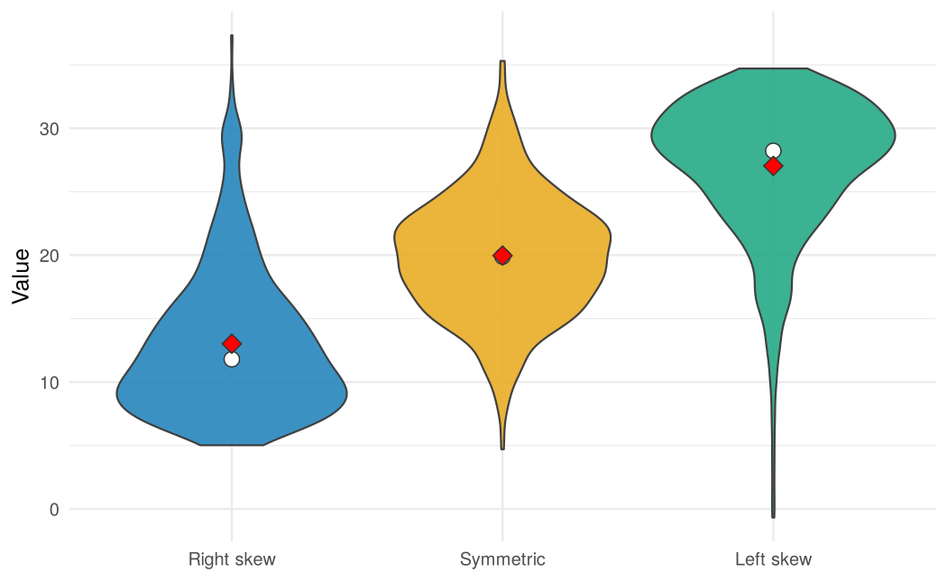
Figure 1: Simulated example. White dot = median, red diamond = mean (above the median for right skew, below it for left skew, on it for symmetric).

Part A – Chart-by-Chart Answers [18 marks]

Chart 1: Order value (Rs hundred) [4.5 marks]
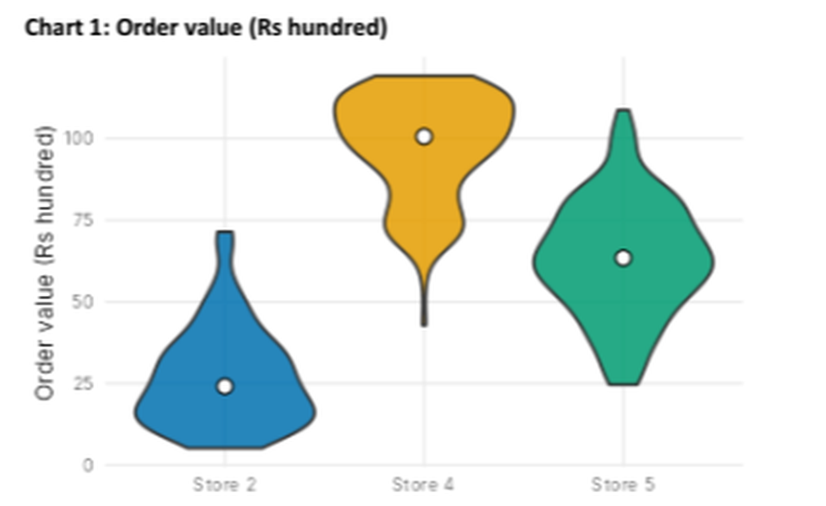
Chart 1: Order value (Rs hundred) (from the activity sheet)
Violin | Skew (circle one) [1] | Mean vs Median (circle) [0.5] | Why (evidence from the chart)
Store 2 | Right / Left / Symm. | Mean > / < / ~ Median | Widest part is low (about 5–25). A thin tail stretches up to about 72. Median (≈ 24) sits low. The tail is on the high side.
Store 4 | Right / Left / Symm. | Mean > / < / ~ Median | Widest part is high (flat, wide top at about 100–118). A thin tail stretches down to about 43. Median (≈ 100) sits high. The tail is on the low side.
Store 5 | Right / Left / Symm. | Mean > / < / ~ Median | Widest in the middle (≈ 63) and balanced on both sides (about 25 to 108). Median (≈ 63) is at the centre.

Chart 2: Battery life (hours) [4.5 marks]
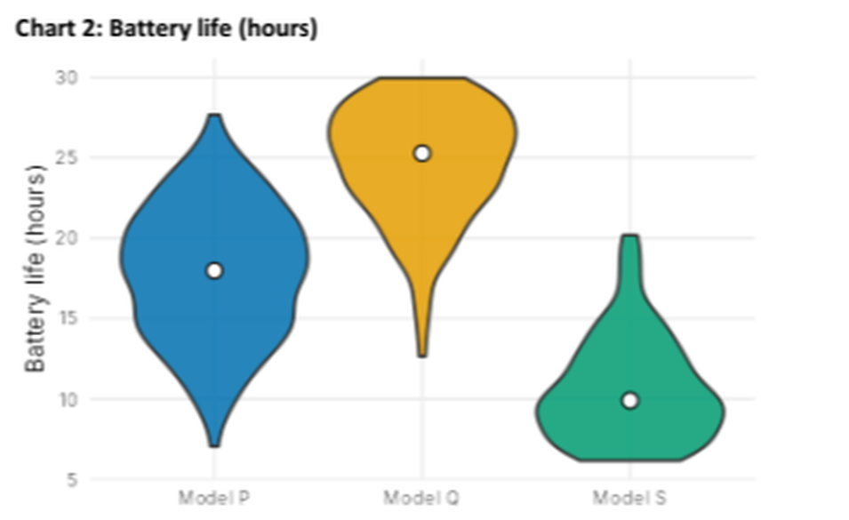
Chart 2: Battery life (hours) (from the activity sheet)
Violin | Skew (circle one) [1] | Mean vs Median (circle) [0.5] | Why (evidence from the chart)
Model P | Right / Left / Symm. | Mean > / < / ~ Median | Widest in the middle (≈ 18) with equally long tails on both sides (about 7 to 28). Median (≈ 18) is at the centre.
Model Q | Right / Left / Symm. | Mean > / < / ~ Median | Widest part is high (flat, wide top at 30). A thin tail stretches down to about 13. Median (≈ 25) sits high. The tail is on the low side.
Model S | Right / Left / Symm. | Mean > / < / ~ Median | Widest part is low (about 6–12). A thin tail stretches up to 20. Median (≈ 10) sits low. The tail is on the high side.

Chart 3: Commute distance (km) [4.5 marks]
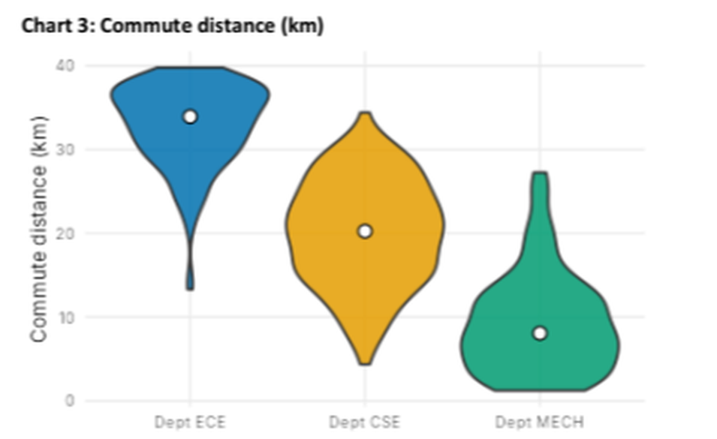
Chart 3: Commute distance (km) (from the activity sheet)
Violin | Skew (circle one) [1] | Mean vs Median (circle) [0.5] | Why (evidence from the chart)
Dept ECE | Right / Left / Symm. | Mean > / < / ~ Median | Widest part is high (flat, wide top at 40). A thin tail stretches down to about 13. Median (≈ 34) sits high. The tail is on the low side.
Dept CSE | Right / Left / Symm. | Mean > / < / ~ Median | Widest in the middle (≈ 20) with similar tails on both sides (about 5 to 34). Median (≈ 20) is at the centre.
Dept MECH | Right / Left / Symm. | Mean > / < / ~ Median | Widest part is low (about 1–12). A thin tail stretches up to about 27. Median (≈ 8) sits low. The tail is on the high side.

Chart 4: Fuel efficiency (km per litre) [4.5 marks]
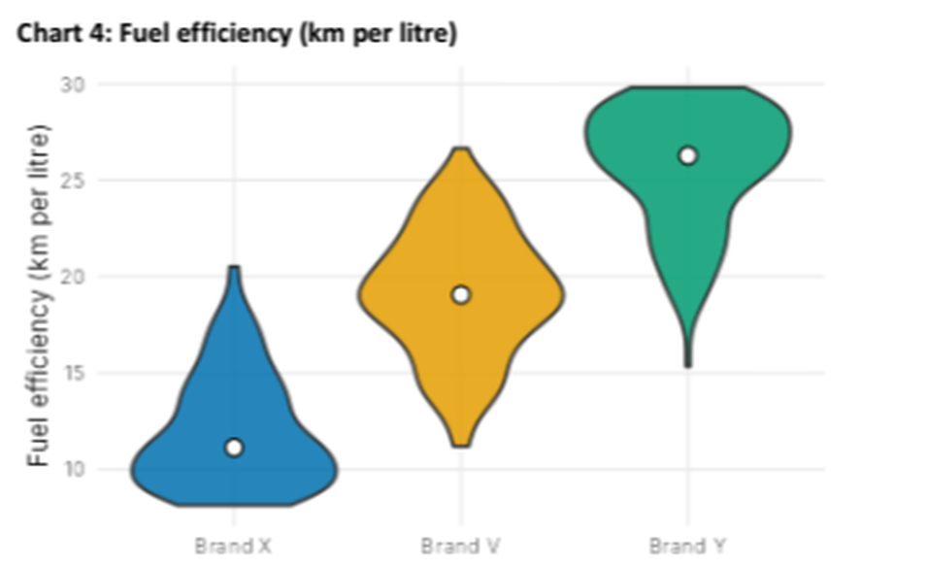
Chart 4: Fuel efficiency (km per litre) (from the activity sheet)
Violin | Skew (circle one) [1] | Mean vs Median (circle) [0.5] | Why (evidence from the chart)
Brand X | Right / Left / Symm. | Mean > / < / ~ Median | Widest part is low (about 8–13). A thin tail stretches up to about 20. Median (≈ 11) sits low. The tail is on the high side.
Brand V | Right / Left / Symm. | Mean > / < / ~ Median | Widest in the middle (≈ 19) with similar tails on both sides (about 11 to 26). Median (≈ 19) is at the centre.
Brand Y | Right / Left / Symm. | Mean > / < / ~ Median | Widest part is high (flat, wide top at 30). A thin tail stretches down to about 15. Median (≈ 26) sits high. The tail is on the low side.

Part B – Detailed Answers [2 marks]

B1. Brand X in Chart 4: tail side and better measure [1 mark]
In Chart 4, violin "Brand X" is not symmetric. Towards which side is its tail, and which is the better measure of a typical fuel efficiency here: mean or median? Give one reason.
- Tail side: the tail is towards the higher values (the upper, right-hand side, up to about 20 km per litre). The widest part is low (about 8–13), so Brand X is right-skewed.
- Better measure: the median.
- Reason: the few high values in the tail pull the mean upwards, so the mean would overstate what a typical car gives. The median is not affected by extreme values, so it shows the typical fuel efficiency (about 11 km per litre) more truthfully.

B2. One ggplot2 line: violins of value for each group, with the median shown [1 mark]
Write one ggplot2 line that draws violins of value for each group from a data frame df (columns group, value), with the median shown.
ggplot(df, aes(x = group, y = value)) + geom_violin() + stat_summary(fun = median, geom = "point")

Part of the line | What it does
ggplot(df, aes(x = group, y = value)) | Uses the data frame df; group on the x-axis, value on the y-axis, so there is one violin for each group
geom_violin() | Draws the violin (the mirrored density curve) for each group
stat_summary(fun = median, geom = "point") | Calculates the median of value in each group and draws it as a dot

To get the white dot used in the activity charts, add shape = 21, fill = "white", size = 3 inside stat_summary():
ggplot(df, aes(x = group, y = value, fill = group)) + geom_violin() +
stat_summary(fun = median, geom = "point", shape = 21, fill = "white", size = 3)

Another way: geom_violin(draw_quantiles = 0.5) draws a line at the median inside each violin instead of a dot.
Check: the lines were run in R (ggplot2 3.4.4) on example data with three groups. The dot was drawn exactly at each group's median (11.8, 19.88 and 28.22), as the output below shows.
Mean and median of each simulated group:
Mean Median Relation
Right skew 13 11.8 Mean > Median
Symmetric 20 19.9 Mean ~ Median
Left skew 27 28.2 Mean < Median
ggplot(df, aes(group, value)) + geom_violin() + stat_summary(median point) OK
... with white dot (shape 21, fill white) OK
ggplot(df, aes(group, value)) + geom_violin(draw_quantiles = 0.5) OK
Dot heights from the stat_summary layer : 11.8 19.88 28.22
Medians computed directly : 11.8 19.88 28.22

